INDUSTRIAL PRACTICES FINAL REPORT
Online Social Network Message Anonymization
at National Institute of Technology, Gifu College

Proposed for fulfilling the pass requirements of
IF4090 Industrial Practice Course

by :
Geraldi Dzakwan / 13514065



INFORMATICS ENGINEERING STUDY PROGRAM
SCHOOL OF ELECTRICAL ENGINEERING & INFORMATICS
BANDUNG INSTITUTE OF TECHNOLOGY
2017
Informatics Engineering Study Program Approval Sheet
Online Social Network Message Anonymization
at National Institute of Technology, Gifu College

by :
Geraldi Dzakwan / 13514065

approved and validated as
Industrial Practice Final Report

Bandung, ____ _______________ 2017
ITB Informatics Engineering Study Program Industrial Practice Supervisor

Dr. Eng. Ayu Purwarianti, S.T., M.T.
NIP: 19770127 200801 2 011
Approval Sheet
Online Social Network Message Anonymization
at National Institute of Technology, Gifu College

by :
Geraldi Dzakwan / 13514065

approved and validated as
Industrial Practice Final Report

Motosu, ____ July 2017
Electrical and Computer Engineering Department Professor

Prof. Makoto Yasuda
ID :
Abstract

This final report is for my industrial practice at National Institute of Technology, Gifu College. I did research about Online Social Network Message Anonymization. This type of anonymization is relatively new because it takes raw text (social media message) as the input instead of structured input like commonly found in k-anonymization techniques (e.g. for anonymizing medical record database). The research is done at Artificial Intelligence lab under the supervision of Prof. Makoto Yasuda.

The method used in the research mainly involve machine learning and natural language processing techniques. The first step is to do some preprocessings for the text (e.g. stemming) to clear unuseful information. Next step is to determine the named entities from raw text. I did some experiments using several classifiers (Naive Bayes, Perceptron, etc.) and using state of the art algorithm (Conditional Random Field). I ended up choosing CRF algorithm as it produces better result. Then, for each type of named entity there will be it’s own mechanism to determine whether it is a private phrase using steps like calculating co-occurence metrics with user profile and executing rule-based approach. Next, the detected private named entity will be anonymized in a specific way according to it’s type. Finally, there are some post processings to produce the final anonymized message.

The result of the program is good at detecting named entity, with the accuration above 80%. But, the private named entity detection still needs to be improved since there are many other cases/patterns to cover. Often in my program, there are cases when private phrases are not anonymized or vice versa (non-private phrases are anonymized). One of the solution that may works is to apply co-reference resolution to the private named entity detection step. It basically will determine all the words that refer to the same thing and that may improves the private named entity detection performance.

To sum up, I want to give conclusion about the research substance. There are currently not many anonymization research focusing on raw text. Thus, I hope that this research could be extended furthermore in the future in term of improving performance by applying other methods and also in term of covering other domains/areas. I hope that I can also create similar researchs for other domains, such as for raw company or government documents.

Keywords: online social network, text anonymization, social media message, classifier, conditional random field, private named entity, co-occurence metrics, rule-based approach, phrase generalization, preprocessing, postprocessing, machine learning, natural language processing

Preface

I would like to express my biggest thanks to my internship supervisor, Prof. Makoto Yasuda as he already gave me an opportunity to study in his lab and he also gave me guidances and feedbacks to improve my work results.

I would also like to give my deepest gratitudes to Dr. Eng. Yoshito Ito as the principal of NIT-GC who warmly welcomed me and JASSO which supported me financially to fulfill all my daily expenses while staying in Japan.

My thanks also go to my industrial practice supervisor at ITB, Dr. Eng. Ayu Purwarianti, S.T., M.T. as she always supported me since the preparation for the internship, including documents preparation for Japan visa and for JASSO scholarship.

I would also not forget to give my thanks to all NIT-GC staffs who helped me out in administrative processes (Prof. Koji Tajima, Mr. Michael Makoto Martinsen, and Mr. Isao Tomita) and to all my friends in the lab (Hideki Kano, Ryosuke Okachi, etc.) which I couldn’t mention all individually. Thank you for taking me around Japan and helping me to find the way out of problems I faced during the internship.

Motosu, 19 July 2017
Geraldi Dzakwan

Table of Contents

Informatics Engineering Study Program Approval Sheet i
Approval Sheet ii
Abstract iii
Preface iv
Table of Contents v
List of Terms and Abbreviations vi
List of Tables vi
List of Pictures vi
Chapter I Introduction I-1
I.1 Background I-1
I.2 Scope I-1
I.3 Goal I-1
Chapter II Industrial Practice Work Environment II-1
II.1 Organization Structure II-1
II.2 Project Scope II-1
II.3 Project Description II-1
II.4 Project Schedule II-1
Chapter III Online Social Network Message Anonymiation III-1
III.1 Problem Description III-1
III.2 Solution Design and Implementation III-1
III.3 Result and Analysis III-2
Chapter IV Closing IV-1
IV.1 Conclusion IV-1
IV.2 Suggestion IV-1
References viii
Attachment A. Term of References A-1
Attachment B. Log Activity B-1

List of Terms and Abbreviations

TBD.

List of Tables

TBD.

List of Pictures

TBD.

Pendahuluan

Chapter I

Introduction

This chapter contains introduction about the industrial practice, including background, scope, and goal.

Background
Generally, this internship program aims to develop basic research skill in some specific fields that depends on which laboratory the student will choose and what research topic the student will pick. In addition, this internship program is expected to be a bridge between the two countries, Indonesia and Japan, in order to maintain a good relation, especially between Bandung Institute of Technology (ITB) and NIT, Gifu College. This program is also expected to improve the students’ communication skill from both schools especially in English.

Regarding the research subject, the student will be given several research topics from each laboratory. Then, the students need to choose their preferred laboratory and their preferred topic or they can also propose their own topic (if approved by the laboratory professor). Afterwards, the student will do research project based on the selected topic. The research project will be conducted for 5 to 6 weeks and it will be supervised by the laboratory professor directly. At the end of the internship program, the student shall submit his internship report to the internship supervisor in NIT, Gifu College.

This section (background) is referred from the Term of Reference (TOR) attachment chapter one (objectives).

Scope
In the Electrical and Computer Engineering Department of NIT-GC, there are several laboratories with their corresponding research areas. For this term of internship, there are two laboratories which accept ITB students. They are Prof. Tajima’s laboratory and Prof. Yasuda’s laboratory. Prof. Tajima’s laboratory research areas are Computer Network and IoT. Some research topics which are covered are Online to Offline Computing System, System Development for Linguistic Landscape, and Data Visualizing System. Meanwhile, Prof. Yasuda’s laboratory research area is Artificial Intelligence. Some research topics which are covered are Genetic Algorithm, Metaheuristics, and Fuzzy Logic.

My research topic is “Online Social Network Message Anonymization”. It’s scope is within machine learning and natural language processing. Thus, my research topic belongs to Prof. Yasuda’s laboratory (as ML and NLP are subset of AI).

Goal
The main goal of this research project is to create an anonymization program (API) for social media message which has good accuracy on determining named entities and on determining private phrases. In this context, private phrases all are phrases that may lead to or may identify a person’s identity and phrases that are containing user’s private information (such as location). Despite making the message anonymized, the message still has to be useful in some ways so it can be used for other purposes such as analytics by third parties. So, there are two parameters that should be satisfied by the result (the anonymized message). The result has to guarentee that it close all user’s private information that can lead to his/her identity but at the same time it has to do minimum number of replacement so the result is not far from the original message and the result remains useful.

For further implementation, this anonymization API can be used by messaging applications (such as LINE, WhatsApp, Telegram) to share their message data to third parties. Normally, in today’s practice, messaging applications need to strictly encrypt all the messages so the information can’t be stolen by third parties. But, actually there are many third parties who want to take benefits from social media messages for doing analytics. The analytics result can be used for supporting some business intelligence processes (e.g. for taking decision in digital marketing). Usually, third parties use public data such as user’s tweets to do analytics. But, with this anonymization API they can legally use social media messages (that are already anonymized) for the sake of their analytics. Perhaps this new dataset (social media messages) can bring improvements to their analytics. Meanwhile, messaging applications can also take benefit by monetizing the messages data (e.g. third parties are charged per request made). So, I think this research topic could lead to something good in the future.

Organisasi atau Lingkungan Kerja Praktek

Chapter II

Industrial Practice Work Environment

This chapter contains the details of the workplace (organization) and it’s work environment, including organization structure of Gifu National College of Technology, project scope, project description, and project schedule.

Organization Structure
Generally, NIT-GC organization structure is the same as other colleges organization structure. It consists of some administrative committees and seven departments. Below is the illustration of NIT-GC organization structure.
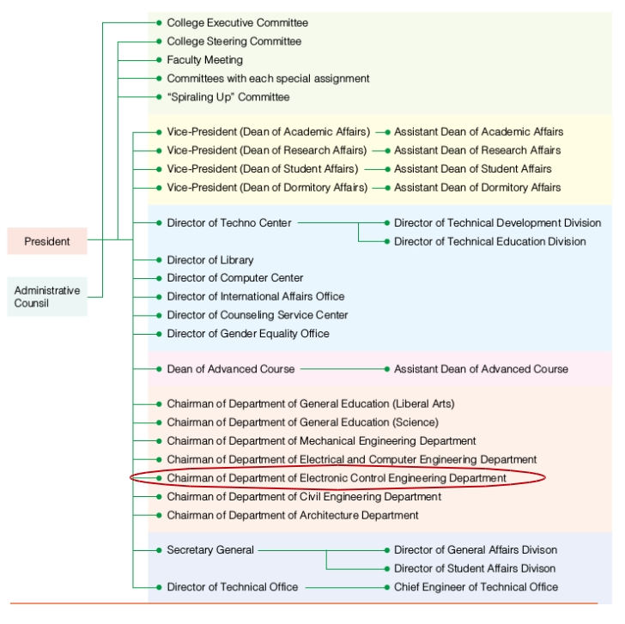

Picture II.1.1 NIT-GC Organization Structure

The lab I was working at (AI Lab, Prof. Makoto Yasuda) is the part of Electrical and Computer Engineering department, highlighted by a red ellipse. Another lab belongs to this department is Computer Network Lab, under Prof. Koji Tajima.

Project Scope
The internship was held at Artificial Intelligence Laboratory and supervised by Prof. Makoto Yasuda. This laboratory is a part of Electrical and Computer Engineering Department as explained in the previous section. This laboratory is responsible for conducting research around AI areas, such as genetic algorithm, metaheuristics, and fuzzy algorithm.

The research that was conducted during the internship program is related to artificial intelligence, especially natural language processing and machine learning. Hence, I was placed in Prof. Yasuda’s laboratory. The research topic is “Online Social Network Message Anonymization”. I carried out two projects, which are training named entity recognizer and creating message anonymization program (API). The description for each project will be explained in the next section.

This section (project scope) is referred from the Term of Reference (TOR) attachment chapter two (project scopes).

Project Description
As mentioned before in the previous section, there are two main projects in the research and below is the description of both projects, explained step by step.

a. Training Named Entity Recognizer

In this project, the student should be able to make a program for predicting named entities from an input word/phrase. The program will use a trained model that will be built using Python Scikit-Learn module (a popular machine learning module in Python). The student will do several experiments using different classifier or algorithm and different data train sample. The student will then decide which model is to be used in the message anonymization API based on the accuracy testing. For the dataset which will be used in training, the student will use Groningen Meaning Bank corpus as so far it is the biggest, most complete, and most suitable English corpus the student has found.

b. Creating Message Anonymization Program (API)

This project is the next step after the first project. This project will use the model which has been created in the first project. The program will probably be in the form of web API, built using either Flask or Django framework. This project will receive an input message (a private message, consisting of one or more sentences, using JSON format) from a client via HTTP POST request. Then, it will do some pre-processing procedures (e.g. sentence tokenizing, POS tagging, NP-chunking and punctuation removal). The result of preprocessing will be delivered to the classifier. The classifier then will return the sentences back to the program with identified named entities. Afterwards, the program will do some post- processing procedures (e.g. correction, co-reference resolution, and sentence restructuring). Last but most important procedure is to apply the anonymization. There are two ways of doing the anonymization, the first one is to replace the named entities with their class or to replace it with another phrase which belongs to the same class so it becomes more natural. The student will try to explore both options. The restructured sentences which have been anonymized then be sent back to the client via JSON message response.

This section (project description) is referred from the Term of Reference (TOR) attachment chapter two (project scopes).

Project Schedule
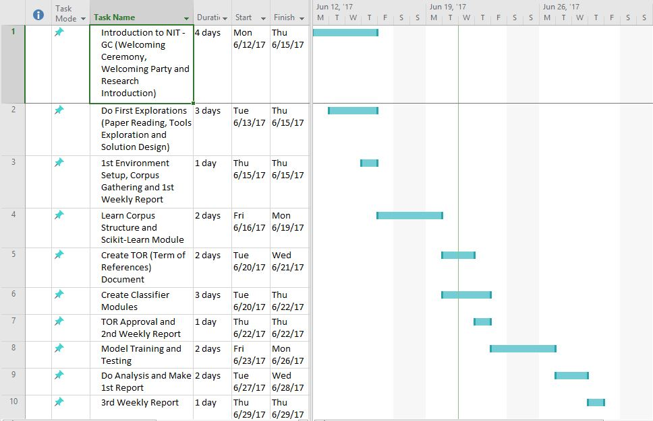
Generally, the student must come to the laboratory every work day (Monday- Friday), from 9.00 a.m. until 16.10 p.m. to work on the research project. Despite that, other activities might take place during research time, such as attending welcoming ceremony and welcoming party, weekly talk café (interacting with NIT-GC students) and giving presentation in some classes. The detailed schedule can be seen below. There are two pictures, the first one shows Gantt chart for the first project and the second one shows Gantt chart for the second project.Picture II.4.1 Project 1 Gannt Chart


Picture II.4.2 Project 2 Gannt Chart

This section (schedule) is referred from the Term of Reference (TOR) attachment chapter eight (schedule).

<Beri Judul sesuai dengan topik KP>

Chapter III

Online Social Network Message Anonymization Implementation

This chapter contains the explanation of how the project is done, including problem description, solution design (step-by-step), implementation, difficulties faced, result, and analysis.

Problem Description
There are two main backgrounds/reasons why I choosed this research topic. The first one is because I want to get some hands on about machine learning and natural language processing. The second one is because there are currently not many anonymization research focusing on raw text. This type of anonymization is different because it takes raw text (social media message) as the input instead of structured input like commonly found in k-anonymization techniques (e.g. for anonymizing medical record database).

The problem description is best explained by stating the research goal itself. The goal is to create an anonymization program (API) for social media message which has good accuracy on determining named entities and on determining private phrases. In this context, private phrases all are phrases that may lead to or may identify a person’s identity and phrases that are containing user’s private information (such as location). Despite making the message anonymized, the message still has to be useful in some ways so it can be used for other purposes such as analytics by third parties. So, there are two parameters that should be satisfied by the result (the anonymized message). The result has to guarentee that it close all user’s private information that can lead to his/her identity but at the same time it has to do minimum number of replacement so the result is not far from the original message and the result remains useful.
Regarding the research project, there are some constraints. The followings are some constraints that are applied throughout the first project about training named entity recognizer:
1. The programming language used is Python version 2.7.10.
2. The English corpus dataset used is Groningen Meaning Bank (GMB) corpus version 2.2.0.
3. The main machine learning tools used for training the model is Python Scikit-Learn version 0.17.
4. The classes of named identity that can be identified are limited to: person name, location/geographical entity, organization, geopolitical entity, and time indicator.
5. Accuracy testing will be done by split test, which is separating train dataset and test dataset from the corpus.

The followings are some constraints that are applied throughout the second project about creating message anonymization program:
1. The programming language used is Python version 2.7.10.
2. The main tools for doing natural language processing techniques are Python NLTK (Natural Language Toolkit) version 3.2.4.
3. The framework used for creating web API is either Flask or Django.
4. The program will only receive private message (a message that has to be anonymized) as the input.
5. Testing will be done by data from GMB corpus and other data that are collected manually by the student.

This section (project description) is referred from the Term of Reference (TOR) attachment chapter four (project constraints).

Solution Design and Implementation
We will first take a look to the big picture of anonymization solution design. In a nutshell, it looks like this:
- Kasi flowchart skema. Setelah classifier udah jadi, baru terangin skema besar anonymization mulai dari preprocessing sampe post processing. Pake GAMBAR DRAW.IO.
- Jelasin preprocessing (stemming, lemmatization)
The first step to be done is to do some preprocessings. There are four main things inside the preprocessings, which are tokenization, pos tagging, stemming, and lemmatization. Tokenization is an activity to split a sentence into a sequence of tokens, which roughly correspond to "words". Meanwhile, POS (Part-Of-Speech) Tagging is an activity to read text and assigns parts of speech to each token, such as noun, verb, adjective, etc. In this project, I use Penn Treebank type of pos tag. The pos tags list can be seen here :
https://www.ling.upenn.edu/courses/Fall_2003/ling001/penn_treebank_pos.html
The tokenization and pos tagging procedure is done by using nltk.word_tokenize and nltk.pos_tag library. This pos tag will be used later as a feature for other processes, such as lemmatization and named entity recognition.

Next process is stemming and lemmatization. Stemming is the process of reducing inflected (or sometimes derived) words to their word stem, base or root form. Stemmers use an algorithmic approach of removing prefixes and suffixes. The result might not be an actual dictionary word. For example, the word “fishing”, “fished”, and “fisher” will be stemmed to the root word “fish”. Meanwhile, lemmatization is a kind of similar process. But, lemmatizers always returns a dictionary word as it uses a corpus and it needs extra info about the part of speech they are processing (e.g. “calling” can be either a verb or a noun). Lemmatization even can turn past tense verb to present tense verb (e.g. went to go) but it is way slower than stemmers. The stemming is done by using SnowballStemmer library and lemmatization is done by using the WordNetLemmatizer library. These two processes are needed to normalize the text and clear unnecessary informations.

- Jelasin feature dan experiment pake perceptron, naive bayes, dan conditional random field. Screenshot akurasi, bandingkan.
Next, I will explain about the named entity classifier, a very important part of this project. The main corpus dataset that I used is Groningen Meaning Bank classifier version 2.2.0 which could be found here (http://gmb.let.rug.nl/data.php). In the classification, I define eight classes/entities, which are :
1. per (person’s name)
2. geo (location)
3. org (organization)
4. tim (time indicator)
5. gpe (geopolitical entity)
6. eve (event)
7. art (artifact)
8. nat (natural phenomenon)

# Statement ini pikirin lagi, sebenernya event sama gpe bisa jadi private
But, only the first six entities would be processed further to detect private phrases. That is because the last two entities are arguably not private informations, thus they don’t have to be anonymized. There is also a concept called IOB tag which described as below.
1. B-entity means that it is the first word of named entity.
2. I-entity means that it is the word inside a chunk/entity.
3. O means that the word is outside of chunk or not a part of named entity.
For example, there is a sentence ‘John Smith is a student’. Then, the word John would be tagged as B-person, the word Smith would be tagged as I-person and the rest of the words are tagged as O.

For the classifier, my first try is to use Naive Bayes and Perceptron. There are some features that I extracted from the words in each sentence in the dataset to be learned by the classifier. The features that are used are:
1. POS (Part-Of-Speech) tag
2. Feature 2
3. Feature 3

Accuracy testing is done by splitting the data train and data test. Data train consists of 90% of whole dataset while data test consists of 10% of whole dataset. Below is the result for each classifier.
Naive Bayes accuracy:
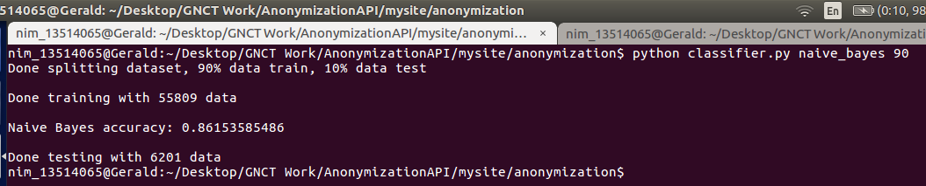

Picture III.2.1 Naive Bayes classifier accuracy
Perceptron accuracy:
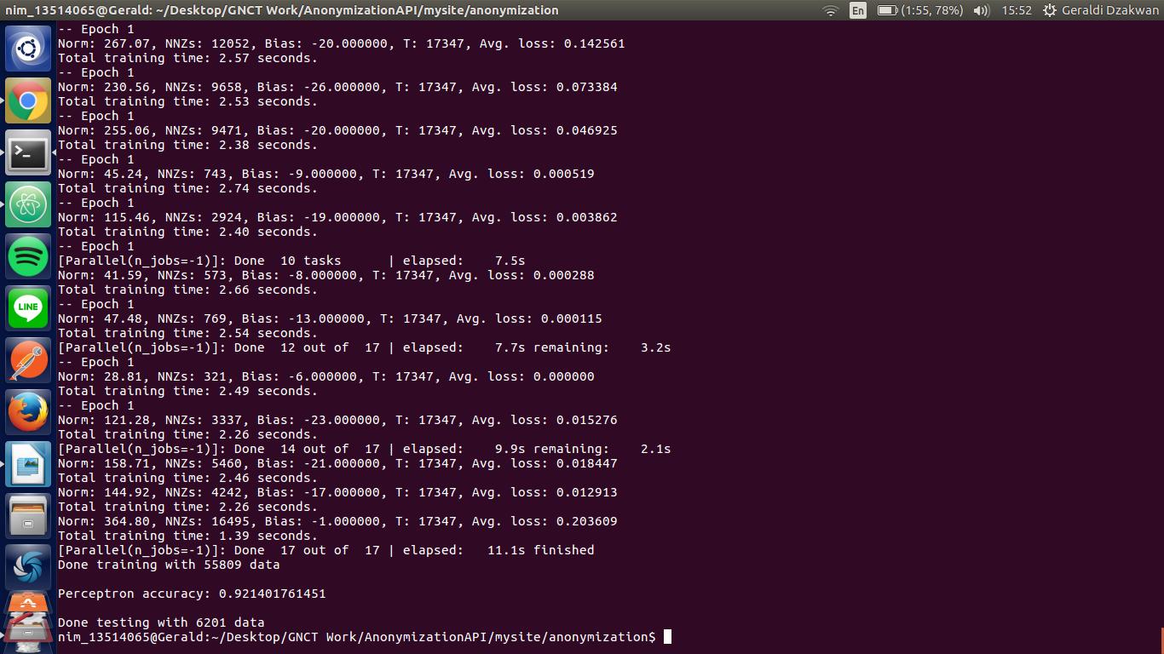
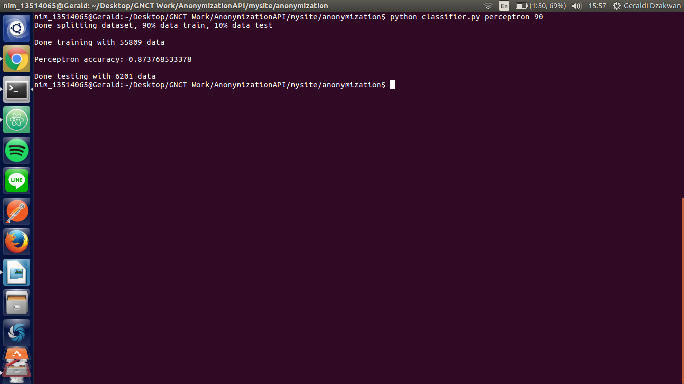

Picture III.2.2 Perceptron classifier accuracy
We might see that the accuracy is pretty high (above 80%). But, actually it isn’t as there are only 10-20% of words in the dataset that have named entity/class. Most of the words (>80%) in dataset are not named entity or tagged as O (don’t belong to one of the eight classed defined). If we predict that all words have O tag (again, O stands for outside any entity), we will achieve at least 80% accuracy. Thus, this named entity classifier is quite poor (not really good).

So, I try to find another method/algorithm to do the named entity recognition. After exploring some alternatives, I ended up choosing an algorithm called Conditional Random Field. Conditional random fields (CRFs) are a class of statistical modeling method often applied in pattern recognition and machine learning and used for structured prediction. CRFs fall into the sequence modeling family. Whereas a discrete classifier predicts a label for a single sample without considering "neighboring" samples, a CRF can take context into account; e.g., the linear chain CRF (which will be used) predicts sequences of labels for sequences of input samples.

The advantage of using CRF is that it uses sentence pattern as its feature. This algorithm computes the probability of transitions between classes. For example, in my case, the algorithm learns that it is more likely to transit from B-ORG to I-ORG than to any other classes. This is perhaps because in the dataset I used, organization entities usually consist more than a word. This is the detail of most likely and unlikely transitions.
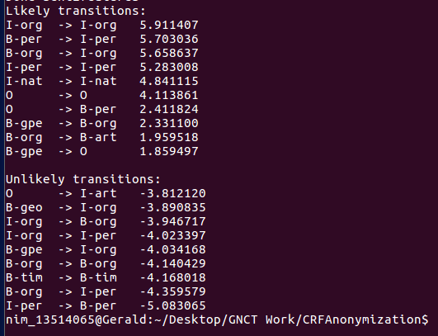

Picture III.2.3 CRF transitions

As the result, CRF model has higher accuracy than the two previous models. Below are the accuracy and confusion matrix of the CRF model. The first picture depicts testing including words with O label while the second picture depicts testing ignoring words with O label.
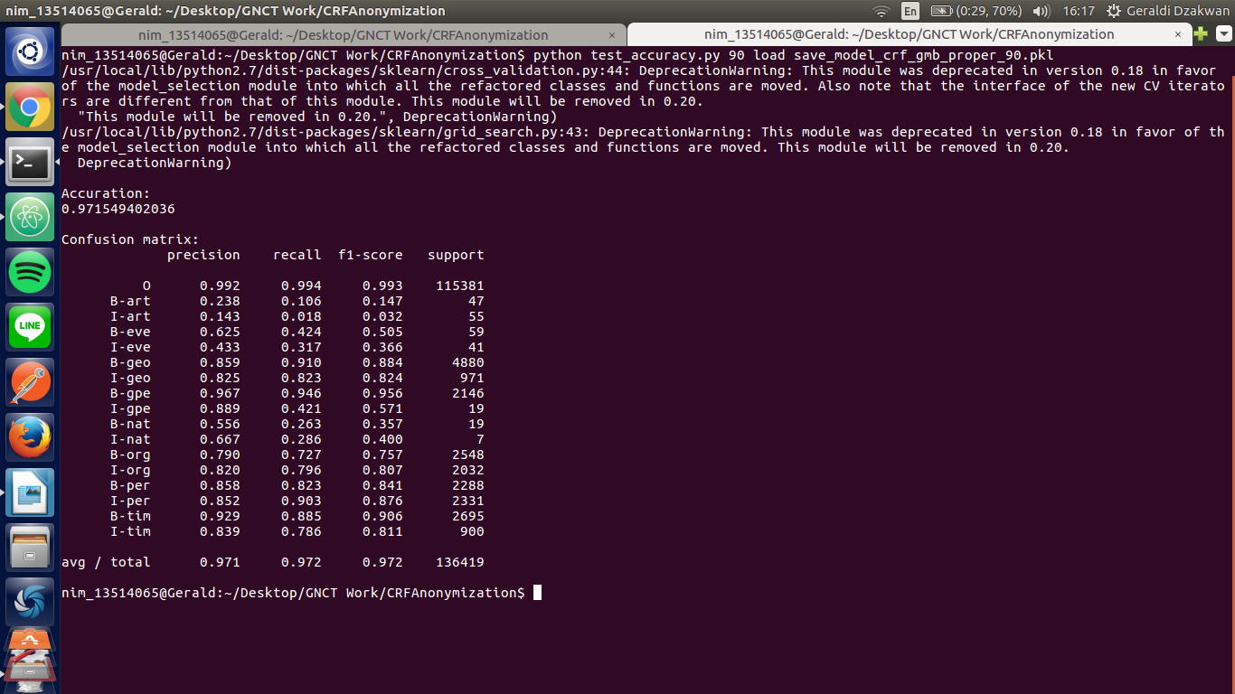

Picture III.2.4 CRF model accuracy ignoring ‘O’ label

Picture III.2.5 CRF model accuracy ignoring ‘O’ label
- Jelasin feature
- Jelasin named entity recognition sama chunking
We use the CRF classifier to predict the named entity of each token. There are three possibilities, which are B tag, I tag, or O tag. For each consecutive B-tag and I tag, the program will combine the chunks to become one whole chunk. For example, the sentence ‘John Smith is a student’ will be tagged as below.
John, B-per – Smith, I-per – is, O – a, O – student, O.
Then, the program will combine all consecutive B-tag and I-tag and it will look like this afterwards.
John Smith, per – is, O – a, O – student, O.

As stated before, the goal of the project is the anonymized message should guarantee that it close all informations that can identify a person. But, in the same time it has to do minimum number of replacement so the result is not far from the original message and the result remains useful. Thus, there must be a mechanism which make sures only private word/phrase that are replaced. So, I proposed two steps to achieve those goals. The first step is to do rule based approach to determine the private phrases. The second step is to calculate co-occurence metrics between detected named entities to user profile.

- Jelasin rule based approach untuk masing-masing entity
The first step is the rule based approach. The rule for each entity has a little bit difference but they have a based common framework. The steps for rule based approach are as below.

1. Extracting candidate phrases
A candidate phrase p is defined as a phrase that begins with the word “I” or “My” and ends with a locational entity, personal entity, or organizational entity. p is also checked whether it contains dot (‘.’) as full stop punctuation. If it does, then it is excluded from candidate phrases. This is needed to avoid creating candidate phrases from more than one sentence. The candidate phrase p extracted will be processed further to the next steps.

2. Checking negative phrases
p is checked if it has negative meaning or includes negative words (like not, no, ain’t, and never). If p has negative meaning then it will not be processed further as it doesn’t contain private information. Otherwise, if p doesn’t have negative meaning, then it will be processed further to the next steps.

3. Checking non-private verbs/nouns
p is checked if it contains at least one non-private locational verbs/nouns, non-private personal verbs/nouns, or non-private organizational verbs/nouns. These verbs/nouns are stored in the MySQL database so it can be extended easily. If p contains non-private verbs/nouns then it will not be processed further as it doesn’t contain private information. Otherwise, if p doesn’t contain non-private verbs/nouns, then it will be processed further to the next steps.

4. Checking private verbs/nouns
p is checked if it contains at least one non-private locational verbs/nouns, non-private personal verbs/nouns, or non-private organizational verbs/nouns. These verbs/nouns are stored in the MySQL database so it can be extended easily. If p contains non-private verbs/nouns then it will not be processed further as it doesn’t contain private information. Otherwise, if p doesn’t contain non-private verbs/nouns, then it will be processed further to the next steps.

Below are sample verbs/nouns for locational entities.

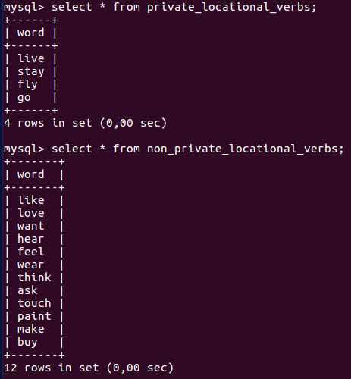

Picture III.2.6 Sample verbs/nouns for locational entities

The temporal/time entity is approached in a rather different way. I found that most temporal entity comes in a fix pattern. So, I create a regex-based temporal entity recognition. Here are some basic patterns that I used:

1. day_regex = day_preposition (on | this | next | last) + days (Monday .. Sunday) + day_details* [morning | afternoon | evening | night]. Some phrases that match this regex: this Sunday, next Saturday, on Monday morning.
2. hour_regex_1 = hour_preposition (at) + numbers [0..23] + conjunction* [. | :] + numbers* [0..59] + hour_desc* [am | pm]. Some phrases that match this regex: at 2.45 pm, at 2 pm.
3. hour_regex_2 = hour_preposition (at) + hour [one .. twelve] + conjunction* [. | :] + minute [thirty | fourty five | fifteen] + hour_desc* [am | pm]. Some phrases that match this regex: at ten thirty pm, at one pm

These regexes can be combined to create another regex such as day_and _hour = day_regex + hour_regex_1 | hour_regex_2 to cover larger phrases like ‘next Monday evening at 3.40 pm’.

- Jelasin co-occurence metrics sama user profile
The goal of the second step is to determine how close is the connection between the detected named entities and the user profile. I simulate a user profile using a MySQL database and it looks like this:
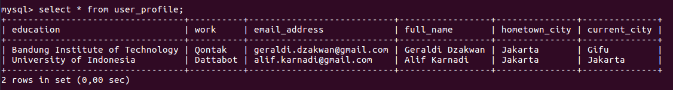
Picture III.2.7 User profile database

Then, there will be comparisons between:
1. PERSON entities with ‘full_name’ to determine if the PERSON entities may have a closed connection to the user (friend, family, etc.)
2. LOCATION entities with ‘hometown_city’ and ‘current_city’ to determine if LOCATION entities in the message may reveal user’s location.
3. ORGANIZATION entities with ‘work’ and ‘education’ to determine if ORGANIZATION entities in the message may reveal where user works.

To calculate the co-occurence metrics, I used Google Custom Search API. It enables me to retrieve the number of web pages that contains at least one of the words or both of the words. The co-occurence metrics are calculated using the formula below.
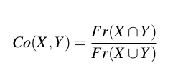

Picture III.2.7 Co-occurence metrics formula

It is a division result between the number of pages that contains both of the words and the number of pages that contains at least one of the word. A high result means that the two words have a closed connection and vice versa (low result means that the two words have a loose connection or no connection at all). For example, the co-occurence metrics value of Tokyo and Japan is 0,078 and the co-occurence metrics value of Tokyo and Korea is 0,047. It means that Tokyo and Japan have a closer connection than Tokyo and Korea as we would expect.
#
After doing several experiments, I decided to put threshold between 0,01 – 0,03. It means that:
1. If the result exceeds 0,03, it is categorized as private word.
2. If the result is below 0,01, it is categorized as non-private word.
3. If it is between 0,01 and 0,03, it will be processed further using rule based approach to determine whether it’s private or not.

There are some reasons why I can’t train a model or doing some statistical aproaches to determine the threshold. It is because Google Custom Search API limits the number of request that can be made per day up to 100 request for free users. I can only use the request for the sake of developing and debugging in this case. I may look for alternatives dataset/API other than Google to use for further improvements on the threshold and co-occurence metrics calculation.

- Jelasin anonymization approach untuk masing-masing entity
After detecting private phrases, anonymizations are done these ways:
1. For personal entity, it would be replaced by another person name with the same gender (woman with woman, man with man). The gender prediction task is done using genderize.io API which is freely available. For the replacement, I create a database containing person’s name. The replacement would be taken from the person database randomly.
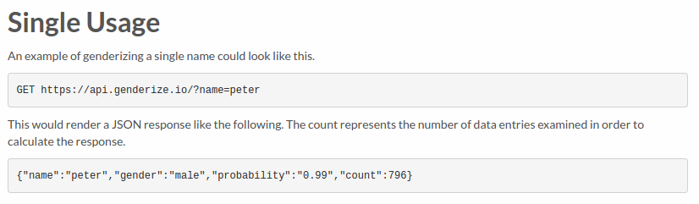

Picture III.2.8 Genderize.io usage

2. For locational entity, it would be replaced by more general entity up by one level or by another entity that belongs to the same general entity if possible (if there is another entity that belongs to the same general entity). The level are as below.
a. Continent
b. Country
c. Subdivision 1
d. Subdivision 2
e. City
These levels are based on a geographical dataset that can be taken from https://dev.maxmind.com/geoip/geoip2/geolite2/. Subdivision 1 and subdivision 2 are similar to a state in USA or to a prefecture in Japan. For example, if there is a private locational word ‘Motosu’ (which is a city), then it would be replaced by ‘a city in Gifu’ (which is a subdivision 1 in the dataset) or by ‘Gero’ (which is a city that belongs to same subdivision Gifu). Below are a small subset from the dataset.
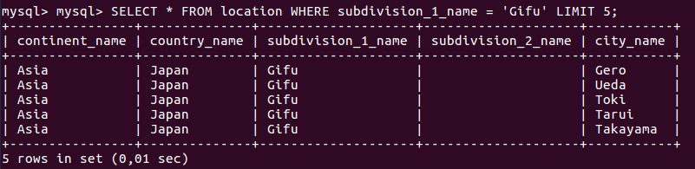

Picture III.2.9 Sample location dataset

3. For organizational entity, it would be ideally replaced by the type of organization/company like ‘tech company’, ‘educational organization’, etc. But, I haven’t figured out how to do this so currently, it would be simply replaced by:
1. ‘a college’ if the organizational entity contains the word ‘university’, ‘institution’, ‘institute’, or ‘college’.
2. ‘an organization’ if the organizational entity contains the word ‘foundation’, ‘organization’, etc.
3. ‘a company’ if the organizational entity doesn’t match the rules above.

4. For temporal/time entity, it would be replaced by more general temporal phrase only if contains specific hour, day, or date. Some examples of replacement are as below.
1. Exact hour (e.g. 2.30 pm). This will be replaced by one of this expression : morning, afternoon, evening, night.
2. Exact day (e.g. Monday). This will be replaced by a general expression like ‘some day this week’.
3. Exact date (e.g. 12 January). This will be deleting the date (e.g. in some day in January).

- Jelasin post processing
After doing the anonymization, the sentences are still wrapped up as tokens. Things to do are to rebuild the sentence to return the result as a text. Ideally, there should be some co-reference resolution mechanism here but I haven’t got time to accomplish. More on why should there be a co-reference mechanism will be explained in the next section.

- Jelasin sentence similarity buat ngukur distance
As stated before, the anonymization has to do minimum number of replacement so the result is not far from the original message and the result remains useful. So, the last step would be measuring sentence similarity to determine how good is the result. In this project, I used WordNet to compute the sentence similarity using properties like Synset and POS tag. The algorithm itself is taken from the paper https://www.aaai.org/Papers/AAAI/2006/AAAI06-123.pdf .

Kasi gambar contoh sentence similarity

Result and Analysis
- Jelasin kenapa conditional random field lebih bagus dibandingkan dengan perceptron dan naive bayes menggunakan data yang sama. Keknya gausa.
- Screenshot beberapa contoh kalimat input dan output dan jelasin prosesnya gimana bisa jadi kaya gitu
In this section, I will give two input examples and explain how my program works to generate the output. The first sentence is ‘My hometown is Jakarta. My favorite food is fried rice. I’ve studied at Bandung Institute of Technology for three years majoring in computer science.’

The first step is to apply the pos tagging, stemming, and lemmatization. We can see that all the words are converted to it’s basic root word/lemma to make the further processing easier. The result is as below.
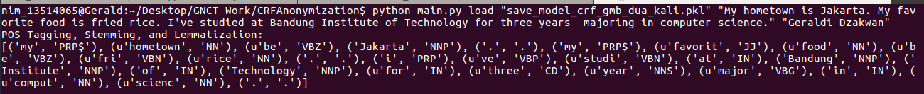
Picture III.3.1 Example 1 step 1
The second step is to apply the named entity recognition and combine all the named entity chunks to one whole chunk. The result is as below.
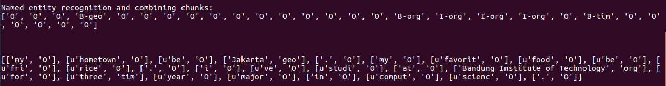
Picture III.3.2 Example 1 step 2
The third step is to detect the private locational candidate phrases and do anonymization with another subdivision/state that belongs to the same country.
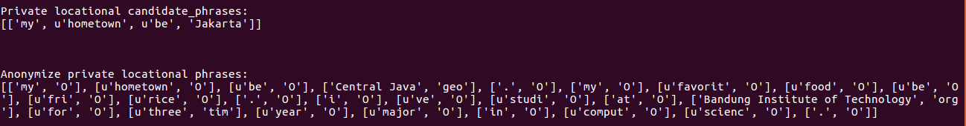
Picture III.3.3 Example 1 step 3
The fourth step is to detect the private organizational candidate phrases and do the anonymization. The result is as below.
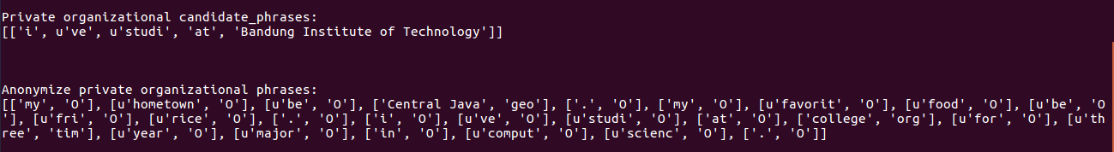
Picture III.3.4 Example 1 step 4
The fifth step is to convert list of normalized token back into a text. We have to also convert back all the words that had been converted to their lemma back to the original words. The last step is to compute sentence similarity to calculate the information loss. The result is 0,83 which means the two sentences have high similarity and low information loss. The result is as below.
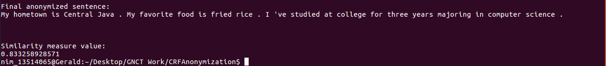
Picture III.3.5 Example 1 step 5
The second sentence is ‘I will meet my sister, Alice, at 3 pm maybe around Motosu.’

The first step is to apply the pos tagging, stemming, and lemmatization. We can see that all the words are converted to it’s basic root word/lemma to make the further processing easier. The result is as below.
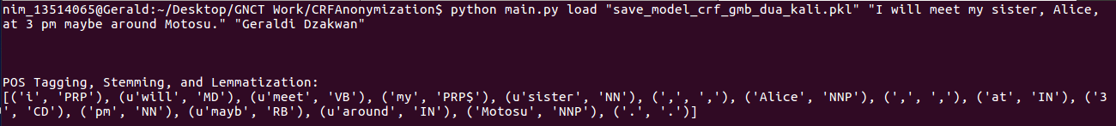
Picture III.3.6 Example 2 step 1

The second step is to apply the named entity recognition and combine all the named entity chunks to one whole chunk. The result is as below.
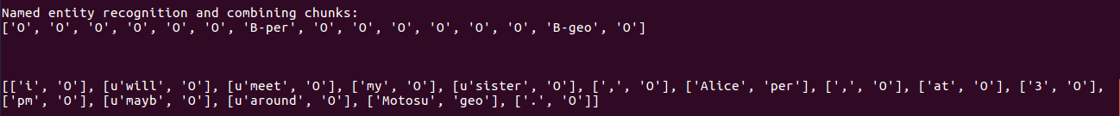
Picture III.3.7 Example 2 step 2

The third step is to detect the private locational candidate phrases and do anonymization with another subdivision/state that belongs to the same country.
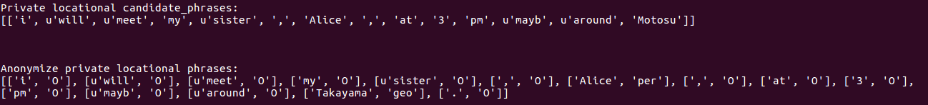
Picture III.3.8 Example 2 step 3

The fourth step is to detect the private organizational candidate phrases and do the anonymization. The result is as below.
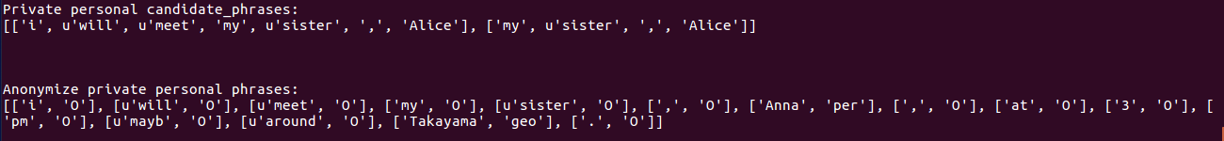
Picture III.3.9 Example 2 step 4

The fifth step is to convert list of normalized token back into a text. We have to also convert back all the words that had been converted to their lemma back to the original words. The last step is to compute sentence similarity to calculate the information loss. The result is 0,83 which means the two sentences have high similarity and low information loss. The result is as below.
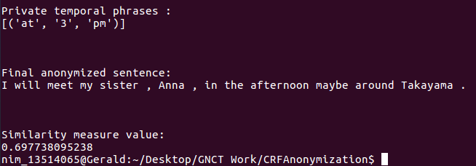

Picture III.3.10 Example 2 step 5

- Jelasin kasus-kasus dimana named entity recognition atau private phrases detection salah.
There are still many cases when the rule based approach fails. For example, if there is any private verbs/nouns that are currently not listed in the database, then it will not be classified as private verbs/nouns by the rule. This case sometime can be covered by the co-occurence metrics step but sometime can’t. For example:
1.
2.

Another case is when rule based approach fails is when there is a word that refers to another word (e.g. he, she, it). Currently, the rule based approach ignore all the phrases starting with he/she/it because I haven’t figured out how to do co-reference resolution to get information about the word that is referred by he/she/it. For example,

- Kalo sempet bikin co-reference resolution, kalo ngk yaudah.

Penutup

Chapter IV

Closing

This chapter contains two closing parts, which are the conclusion and suggestion. The conclusion is derived from the research project the student has completed and also from the work environment in NIT-GC. Meanwhile, the suggestion is about some future works and/or improvements that can be accomplished and the student’s feedback regarding the industrial practice.

Conclusion
To sum up, I want to give two kind of conclusions, one is about the research substance and the other one is about the industrial practice at National Institute of Technology, Gifu College (NIT-GC). Below is for the research substance.

1. To create good named entity recognizer, corpus dataset plays very important roles. Make sure you choose a corpus that suits your problem domain (e.g. in my case I need to make sure that my corpus have sufficient numbers of person, location, and organization entities).
2. Another important factor is the algorithm and the feature you use to train your classifier. In my experiments, conditional random field algorithm did better than other algorithms because it concerns not only a word that is going to be predicted, but also concerns the word before and the word after (linear chain CRF).
3. The private phrases detection still have so many flaws to cover. This is because there are many other patterns that are not included/covered in the rule-based approach method.

Meanwhile, below is for the work environment at NIT-GC.

1. Overall, the industrial practice at NIT-GC is both challenging and fun.
2. It’s challenging because the supervisor always gives you feedbacks and urges you to improve your work.
3. It’s fun of course because it’s Japan. But, it’s more because all the students in the lab are very nice and helpful. They invited me to play board games and to eat some delicious Japanese dishes at the restaurants. They also took me to some beautiful cities in Japan, such as Kyoto, Osaka, and Nagoya in our free time (weekend).
4. It’s fun also because they make the lab as a very nice workplace. Beside computer facilities, they have plenty of board games to play. Even the lecturer play the board games and he just blend with his students as of he is their friends.

Suggestion
I want to give two kind of suggestions, one is about the research substance and the other one is about the industrial practice at National Institute of Technology, Gifu College (NIT-GC). Below is for the research substance.

1. There are currently not many anonymization research focusing on raw text. Thus, I hope that this research could be extended furthermore in the future in term of improving performance by applying other methods and also in term of domains/areas. I hope that I can also create similar researchs for other domains, such as for raw company or government documents.
2. One of the solution that may improves the private phrases detection is to apply co-reference resolution to the private named entity detection step. It basically will determine all the words that refer to the same thing and that may improves the private named entity detection performance. Other solutions are of course to define more rules in the rule-based method.
3. One of the solution that may improves the named entity recognition is to redefine the feature used in the CRF classifier.

Meanwhile, below is for the industrial practice at NIT-GC.

1. For ITB exchange students who are going to do internship next year, it may be good if they are invited to attend some relevant lectures/classes and are involved in student’s experiment activities.
2. It may be good for next year if NIT-GC opens internship opportunity for other departments like Mechanical Engineering, Civil Engineering, or Architecture so it can cover more ITB exchange students.
References

TBD.

Attachment A. Term of References

To sum up, I want to give two conclusions, one is about the research substance and the other one is about the industrial practice at National Institute of Technology, Gifu College (NIT-GC). There are currently not many anonymization research focusing on raw text. Thus, I hope that this research could be extended furthermore in the future in term of improving performance by applying other methods and also in term of domains/areas. I hope that I can also create similar researchs for other domains, such as for raw company or government documents. Overall, the industrial practice at NIT-GC is both challenging and fun. It’s challenging because the supervisor always gives you feedbacks and urges you to improve your work. Meanwhile, it’s fun because it’s Japan and all the students in the lab are very nice and helpful. They will invite you to play games and to eat at some delicious Japanese restaurants. They will also take you to some beautiful cities in Japan, such as Kyoto, Osaka, and Nagoya in the free time (weekend).

Attachment B. Log Activity

